LAB ASSIGNMENT 2

Q Implementation of sorting algorithm using non recursive method.

USING BUBBLE SORT:

Source code:

#include <iostream>

using namespace std;

int main()

{

int n;

cout<<"No of elements in array: ";

cin>>n;

int arr[n];

for(int i=0;i<n;i++)

{

cin>>arr[i];

}

int count=1;

while(count<n)

{

for(int i=0;i<n-count;i++){

if(arr[i]>arr[i+1]){

int temp=arr[i];

arr[i]=arr[i+1];

arr[i+1]=temp;

}

}

count++;

}

for(int i=0;i<n;i++){

cout<<arr[i]<<" ";

}cout<<endl;

return 0;

}

OUTPUT:

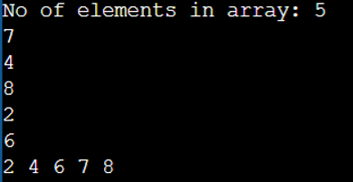

Q Implementation of sorting algorithm using recursive method.

USING SELECTION SORT:

Source Code:

#include <iostream>

using namespace std;

int main()

{

int n;

cout<<"No of elements in array: ";

cin>>n;

int arr[n];

for(int i=0;i<n;i++)

{

cin>>arr[i];

}

{

for(int i=0;i<n-1;i++){

for(int j=i+1;j<n;j++){

if(arr[j]<arr[i]){

int temp=arr[j];

arr[j]=arr[i];

arr[i]=temp;

}

}

}

}

for(int i=0;i<n;i++){

cout<<arr[i]<<" ";

}cout<<endl;

return 0;

}

OUTPUT:

